EXPERIMENT: PROPERTIES OF SIGNALS

OBJECTIVE: To understand the basic properties of signals viz. time shifting, time scaling etc..

PRE-SESSION WORK:

**Basic operations on signals:**

1. **Amplitude scaling**: It is defined by the equation

y[n] = c*x[n]

Where x(t) is the input signal and c is the amplification factor.

This implies that the value of the signal is multiplied by c at every point n.

Eg: An amplifier is a physical device which performs amplification of the signal.

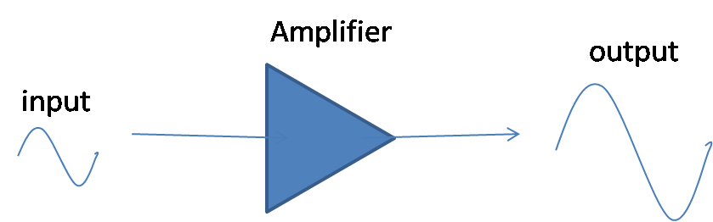

2. **Addition:** It is defined by the equation

y[n] = x1[n] + x2[n]

The values of x1[n] and x2[n] are added at every instant n.

Eg: An audio mixer is an example of an adder. It adds the voice and music signals.

3. **Multiplication**: It is defined by the equation

y[n] = x1[n] * x2[n]

Eg: A DSBSC modulation scheme is an example for multiplication of signals. In DSBSC, the carrier signal is multiplied with the message signal before transmission..

**Operations on independent variable:**

1. **Time scaling**: It is defined as

y[n] = x[an]

where ‘a’ is an integer

2. **Reflection**: It is defined by the equation

y[n] = x[-n]

It is a signal which is a reflected version of the input signal about the amplitude axis.

3. **Time shifting**: It is defined by the equation

y[n] = x[n – n0]

where n0  is an integer.

**Precedence rule for time shifting and time scaling:**

In case of a system function, y[n] = x[an – n0], priority should first be given to time shifting followed by time scaling.

Eg: y[n] = x[2n + 3]

Step 1: Perform time shifting.

Let z[n] = x[n+3]

Step 2: Perform time scaling on the signal z[n]

y[n] = z[2n]

PROCEDURE:

* Load the executable files in Scilab.
* Save the file.
* Go to Execute->Execute in Scilab or press Ctrl-E
* Observe the output with respect to the original waveform.